Social Narrative

Frederick’s Fables



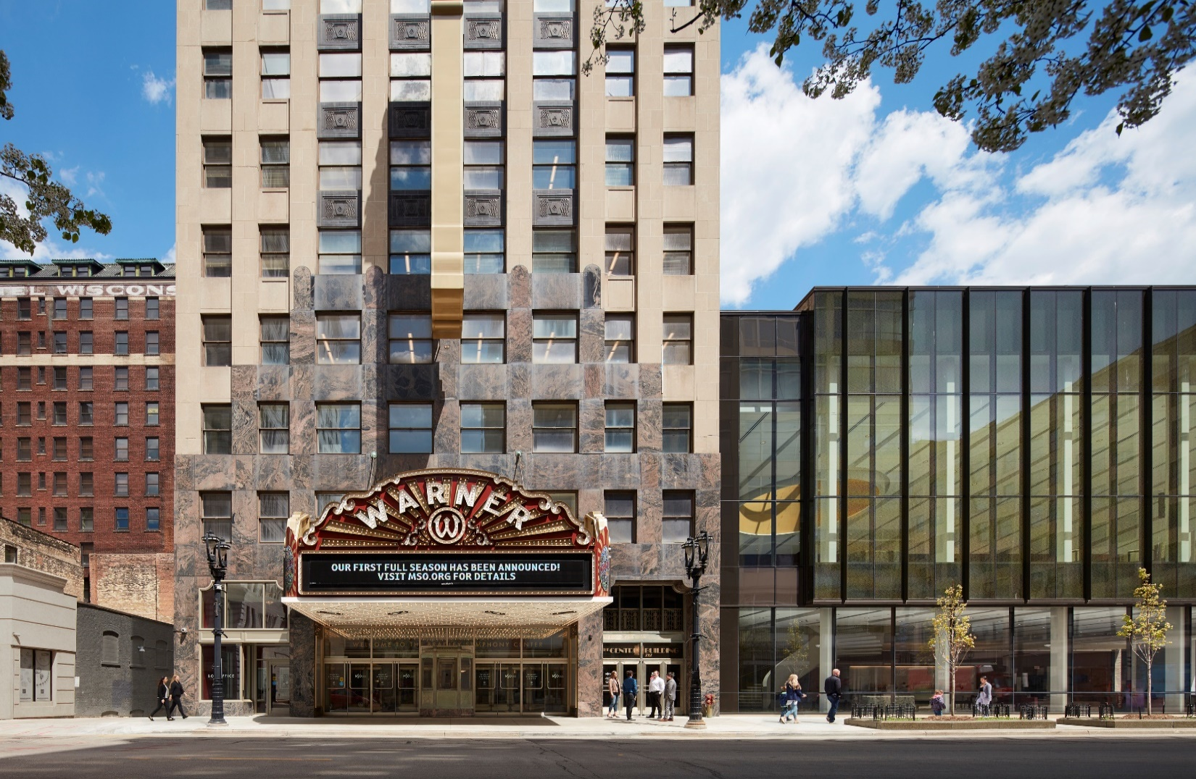

Welcome to the Milwaukee Symphony Orchestra Frederick’s Fables Concert!

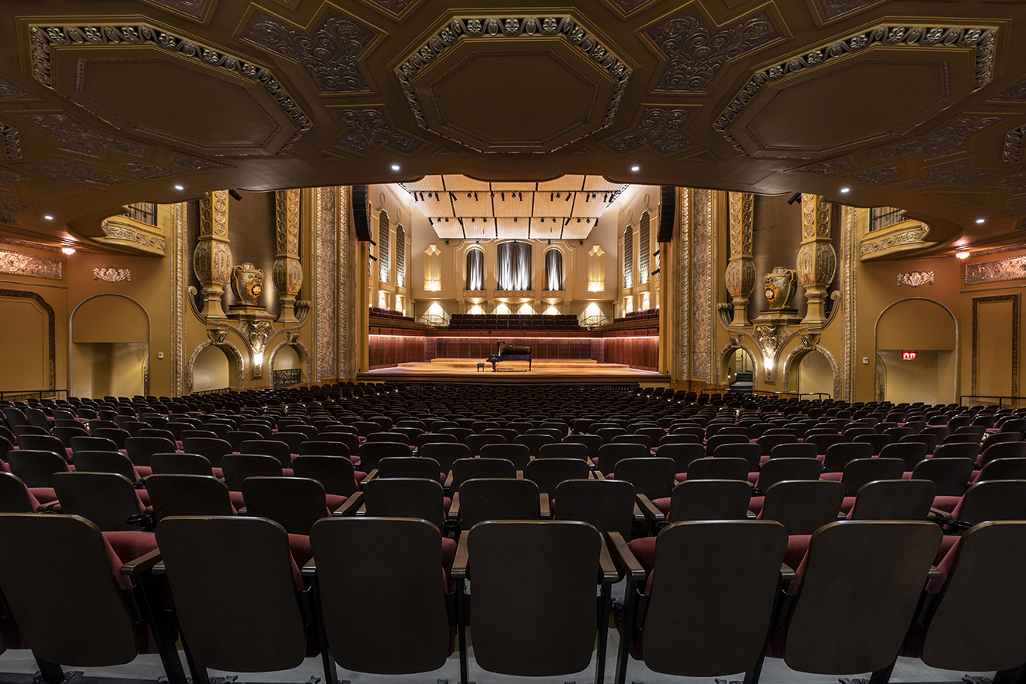

Before the concert begins, I will find my seat with my school in Allen-Bradley Hall!



Assistant Conductor Ryan Tani will be our maestro for today’s performance.



Actors from First Stage will be our host for today’s performance.

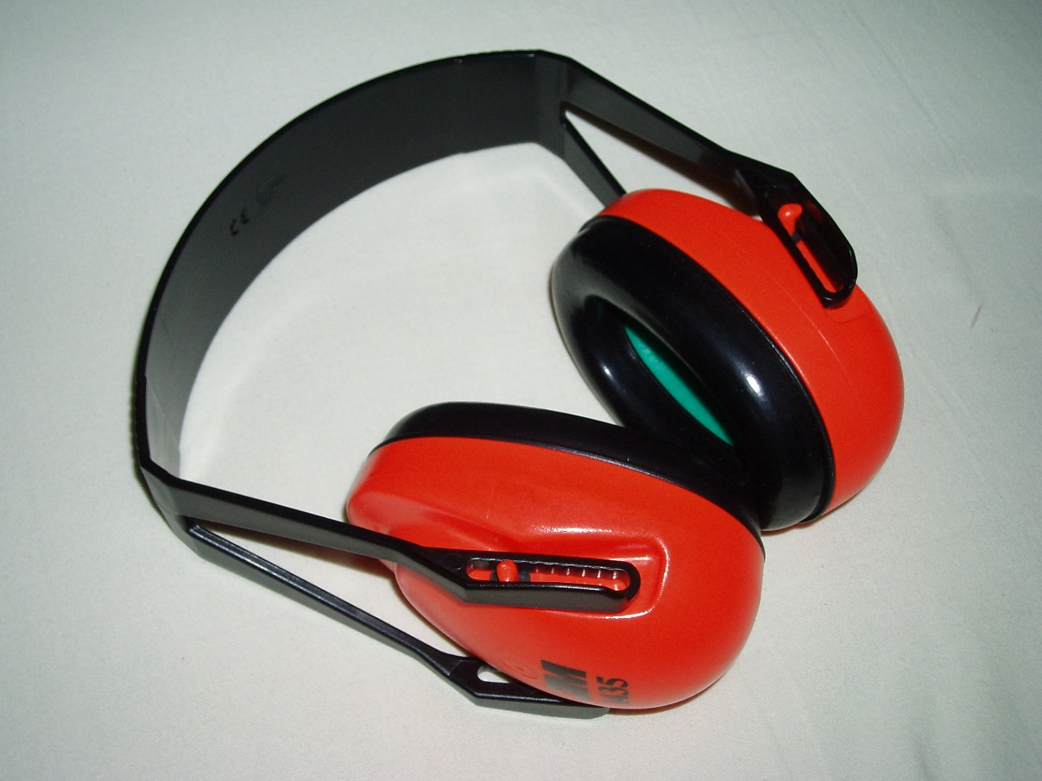

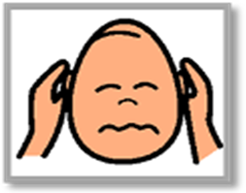

The sounds the orchestra makes will sometimes be loud.

Even though the sounds can be loud and can feel scary, none of the noises can hurt me.

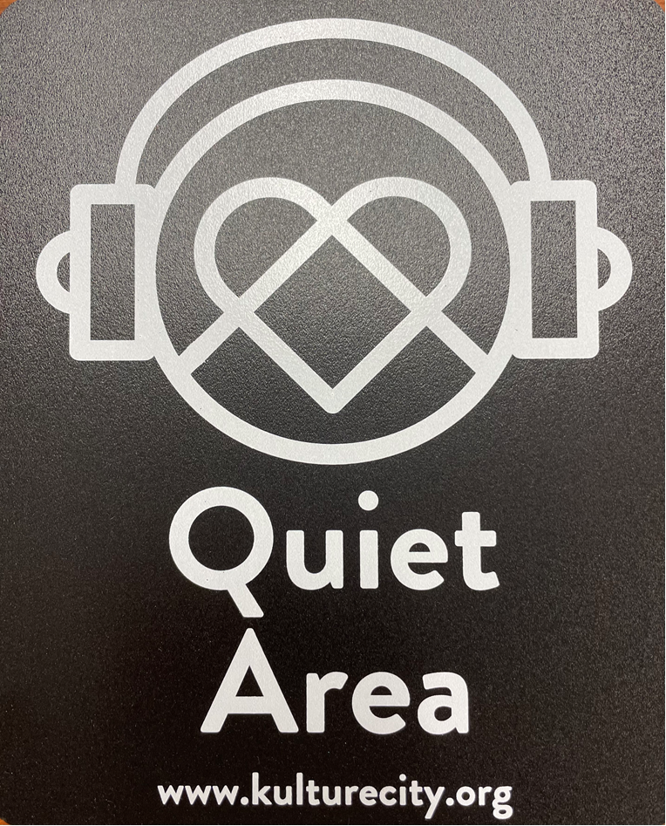
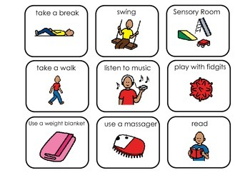

If I need to take a break, I can leave and come back at any time.


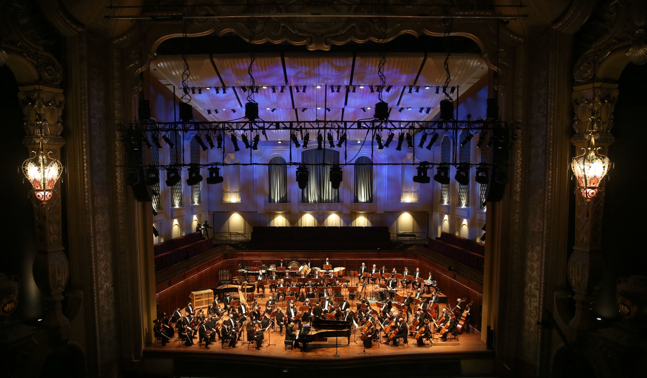
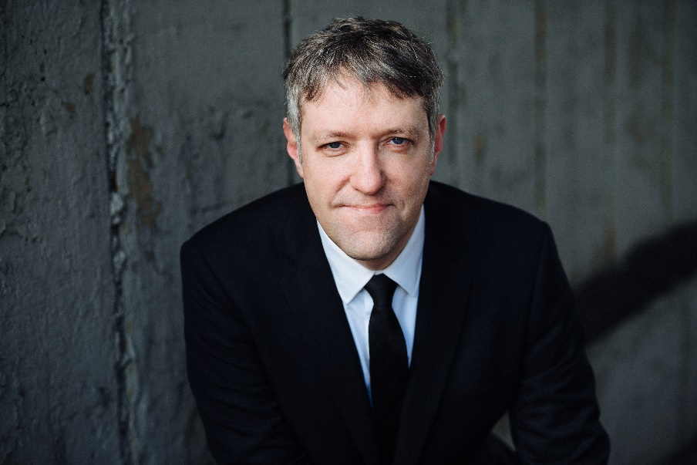

Conductor Ryan, the orchestra, and our friends from First Stage will perform
Movement I. Frederick by Michael Abels with text and illustrations by Leo Leonni

Conductor Ryan, the orchestra, and our friends from First Stage will perform
Movement II. The Greentail Mouse by Michael Abels with text and illustrations by Leo Leonni

Conductor Ryan, the orchestra, and our friends from First Stage will perform
Movement III. Theodore and the Talking Mushroom
by Michael Abels with text and illustrations by Leo Leonni

Conductor Ryan, the orchestra, and our friends from First Stage will perform
Movement IV. Alexander and the Wind-Up Mouse
by Michael Abels with text and illustrations by Leo Leonni



When the performance is over, I can use the ASL sign for applause or clap to thank the conductor and the musicians.



I will wait in my seat until it is time for my group to return to school.

When I get home, I can share what I heard and saw at the symphony with my friends and family.

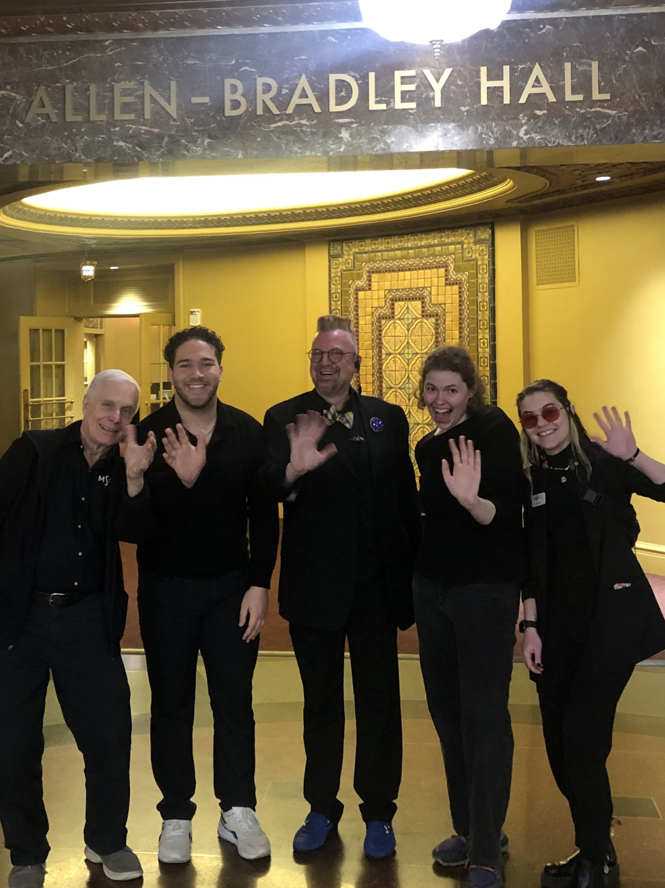

The Milwaukee Symphony Orchestra musicians and staff are so happy you came to the performance today. They look forward to seeing you again!

